GitHub Extension for Visual Studio – Error when trying to connect to GitHub
- When I press the “Connect” button to our GitHub Enterprise on premise, I get the following message. The error message is the same for both new projects and existing GIT projects

The function was working a few days ago.
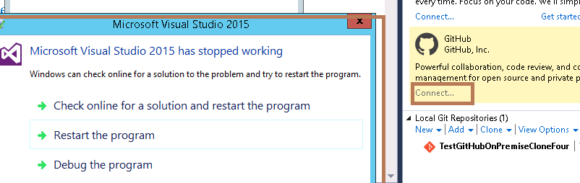

- When I try to press “Debug the program”
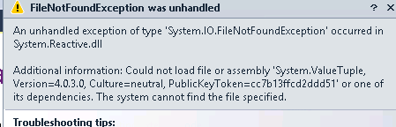
- My version of Visual Studio is
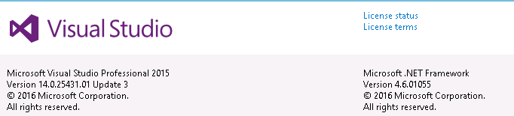
- Please note the following:

- I have removed the GitHub Extension and re-install
- There are no issues using VS 2015
- I can connect using the GIT command line
- The error is consistently repeatable

